**PIZZA SALES SQL QUERIES**

**KPI’s:  
1. Total Revenue:**

SELECT SUM(total_price) AS [Total Revenue] FROM dbo.pizza_sales;  
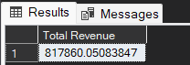  
  
2. Average Order Value:

SELECT SUM(total_price)/COUNT(DISTINCT order_id) AS [Average Order Value] FROM dbo.pizza_sales;

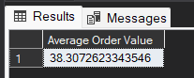

3. Total Pizzas Sold

SELECT SUM(quantity) AS [Total pizza sold] FROM pizza_sales;  
  
  
4. Total Orders

SELECT COUNT(DISTINCT order_id) AS [Total Orders] FROM pizza_sales;

  
  
5. Average Pizzas Per Order

SELECT CAST(CAST(SUM(quantity) AS DECIMAL(10,2)) / CAST(COUNT(DISTINCT order_id) AS DECIMAL(10,2)) AS DECIMAL(10,2)) AS [Avg Pizzas per order] FROM pizza_sales;  
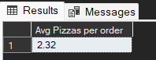

**Daily Trend for Total Orders:**SELECT DATENAME(DW, order_date) AS order_day, COUNT(DISTINCT order_id) AS total_orders

FROM pizza_sales

GROUP BY DATENAME(DW, order_date)

**Output:  
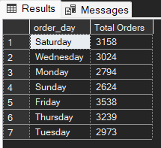**

**Monthly Trend for Total Orders:**select DATENAME(MONTH, order_date) as [Month Name], COUNT(DISTINCT order_id) as [Total Orders]

from pizza_sales

GROUP BY DATENAME(MONTH, order_date)

ORDER BY [Total Orders] DESC;  
**Output:**

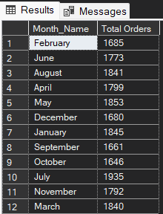  
  
  
  
  
**% of Sales by Pizza Category:**

SELECT pizza_category, SUM(total_price) as [Total_sales] , CAST(SUM(total_price)*100/

(SELECT SUM(total_price) FROM pizza_sales WHERE MONTH(order_date) = 1) AS decimal(10,2)) AS PCT

FROM pizza_sales

WHERE MONTH(order_date) = 1

GROUP BY pizza_category;

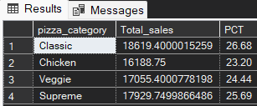  
  
**% of Sales by Pizza Size:**SELECT pizza_size, CAST(SUM(total_price) AS decimal(10,2)) as [Total_sales] , CAST(SUM(total_price)*100/

(SELECT SUM(total_price) FROM pizza_sales WHERE DATEPART(QUARTER,order_date) = 1 ) AS decimal(10,2)) AS PCT

FROM pizza_sales

WHERE DATEPART(QUARTER,order_date) = 1

GROUP BY pizza_size

ORDER BY PCT DESC;

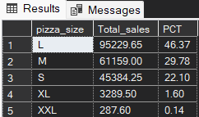  
  
**Total Pizzas Sold by Pizza Category:**

SELECT pizza_category, SUM(quantity) AS [Total Quantity Sold]

FROM pizza_sales

WHERE MONTH(order_date) = 2

GROUP BY pizza_category

ORDER BY [Total Quantity Sold] DESC;  
  
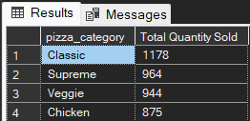  
  
  
  
**Top 5 Pizzas by Revenue:**SELECT TOP 5 pizza_name, SUM(total_price) AS [Total Revenue] FROM pizza_sales

GROUP BY pizza_name

ORDER BY [Total Revenue] desc  
  
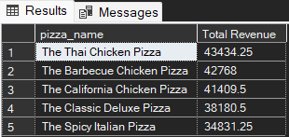  
  
**Bottom 5 Pizzas by Revenue:**  
SELECT TOP 5 pizza_name, CAST(SUM(total_price) AS decimal(10,2)) AS [Total Revenue]

FROM pizza_sales

GROUP BY pizza_name

ORDER BY [Total Revenue] ASC  
  
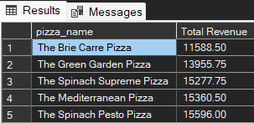

**Top 5 Pizzas by Quantity**

SELECT TOP 5 pizza_name, SUM(quantity) AS [Total Quantity]

FROM pizza_sales

GROUP BY pizza_name

ORDER BY [Total Quantity] DESC;  
  
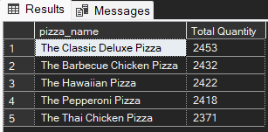

**Bottom 5 Pizzas by Quantity**

SELECT TOP 5 pizza_name, SUM(quantity) AS [Total Quantity]

FROM pizza_sales

GROUP BY pizza_name

ORDER BY [Total Quantity] ASC;  
  
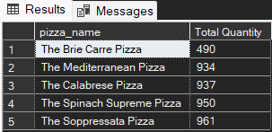

**Top 5 Pizzas by Total Orders:**

SELECT Top 5 pizza_name, COUNT(DISTINCT order_id) AS Total_Orders

FROM pizza_sales

GROUP BY pizza_name

ORDER BY Total_Orders DESC;  
  
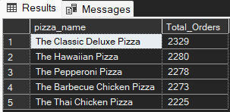  
  
**Bottom 5 Pizzas by Total Orders:**

SELECT Top 5 pizza_name, COUNT(DISTINCT order_id) AS Total_Orders

FROM pizza_sales

GROUP BY pizza_name

ORDER BY Total_Orders ASC  
  
